**Add Image To Blog Page**

**Send Feedback**

Your blog now looks better and seems to be readable.

After knowing how to add an image, you will now do the same in your blog.

So let's add all the images required to your blog. Images to be added are provided at the end of this problem. Remember to add appropriate alternate text as well.

Some text also need to be added to the blog, so add it as well.

**For where to insert them, look at the expected look of the page and add them to their appropriate positions, as shown below-**

[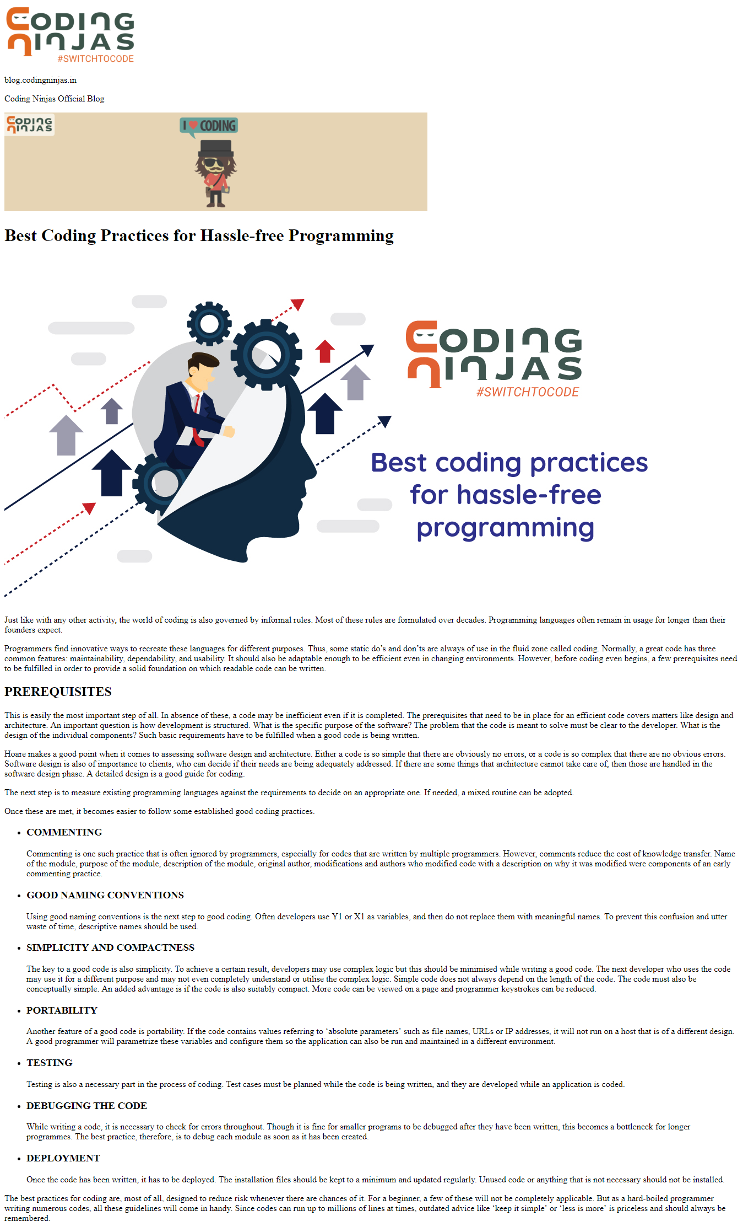](https://ninjasfiles.s3.amazonaws.com/0000000000001396.png)

**The required images are -**

[](https://ninjasfiles.s3.amazonaws.com/0000000000001394.png)

[](https://ninjasfiles.s3.amazonaws.com/0000000000001395.png)

[](https://ninjasfiles.s3.amazonaws.com/0000000000001393.jpg)